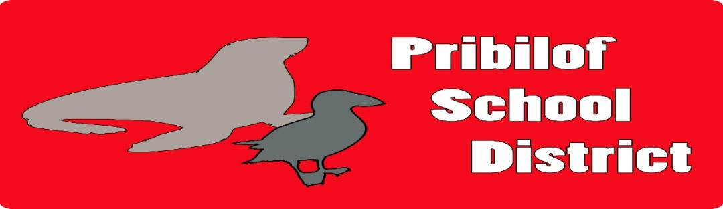

Position Information
Position: Elementary Teacher- Combo class
Reports to: Superintendent / Principal Supervisory: No
Classification: Certified Work Term: School Year
Posted Date: February 16, 2024 Closing Date: Until Filled
Minimum Starting Salary: BA+0= $54,745.

Job Description is below: Applicants should apply through ATP (www.alaskateacher.org)
Please send any application materials to:

Michael Baldwin
Superintendent / Principal
Pribilof School District
PO Box 207
St. Paul Island, AK 99660
E-Mail: baldwinm@pribilofsd.org

This position may be required to complete a pre-employment physical examination drug screening.
Under the direction of the district Superintendent/Principal, the teacher is responsible for the implementation of research-based instructional strategies that direct the learning process and achievement of assigned students by developing, nurturing, and sustaining a school and classroom culture conducive to student learning.
Minimum Qualification Requirements
To perform this job successfully, an individual must be able to perform each essential function satisfactorily. The requirements listed below are representative of the knowledge, skills, and/or abilities required. Reasonable accommodations may be made to enable individuals with disabilities to perform the essential functions.
Qualifications Required Position: Elementary Teacher
- Valid Alaska Teacher’s Certificate with appropriate endorsement in assigned teaching field(s) if required by the State Department of Education. (i.e. Elementary, etc).
- Knowledge of the principles, practices, and procedures.
- Ability to plan, organize, develop, prepare and deliver, under minimal supervision, educational programs to students applicable to the assigned subject(s) and/or grade level(s) and students’ individual abilities.
- Knowledge of curriculum, equipment, materials, and techniques relevant to the assigned teaching area(s).
- Ability to select, train, supervise, and evaluate teacher aides as assigned.
- Ability to relate positively and cooperatively with students, other District employees, and school patrons in the public education environment.
- Ability to maintain proper classroom decorum and discipline in accordance with District policies and procedures.
- Physical condition and agility to pass the required physical examination.
- Ability to carry out successfully the duties described below with minimum supervision.
Preferred:
- Certificate endorsement in the field(s) of teaching assignment.
- Successful teaching experience relevant to the assigned teaching area(s).
Essential Duties and Responsibilities
- Maintain competency in Elementary certification and area of assignment. There could be instances where teachers are assigned to teach subjects outside of their area of preparation.
- Employ appropriate methods of assessment to identify student proficiency levels and subsequently plan short and long-range programs designed to accommodate those identified needs using student formative and summative student achievement data.
- Promote and support School District Goals as defined in the Board of Education Strategic Plan.
- Participate in the activities of educational committees and organizations for the benefit of personal growth and the general promotion of the profession.
- Develop an awareness of local culture and provide instruction that is bicultural or multicultural by responding to diverse community interests and needs.
- Supervise and train instructional paraprofessional in providing services to students as needed. Abide by the code of ethics and the professional teaching standards adopted by the Professional Teaching Practice Commission of the State.
- Write and submit weekly lesson plans to Superintendent/Principal and maintain digital copies throughout the year. Adhere to all District policies and regulations.
- Perform such other tasks and assume other responsibilities as the supervisor may assign.
Physical Requirements
• The physical demands described here are representative of those that must be met by an employee to successfully perform the essential functions of this job.
Environmental Conditions
• The work environment characteristics described here are representative of those an employee encounters while performing the essential functions of this job.
THE PRIBILOF SCHOOL DISTRICT IS AN EQUAL OPPORTUNITY EMPLOYER AND A DRUG FREE WORKPLACE

